- Semi-Smart Watch description
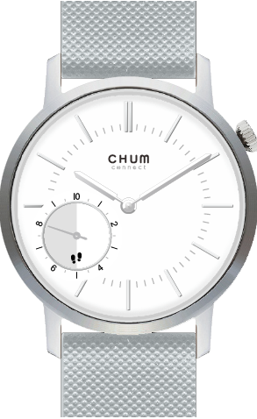

A
C

D
B

Features:
A: Crown for adjusting time
B: Button for step function
C: Time indicator
D: Step indicator

- How to start your Semi-Smart Watch
Semi-Smart Watch is under shipping mode at beginning
- Gently pull out crown(A) to adjust time
- Released shipping mode by press and hold the pusher(B) for 5 seconds
- After released shipping mode, the Pedometer hand should at “0” position
B
A

- Step indicator
- Each gear represents 500 steps
500
- One cycle means 10000 steps
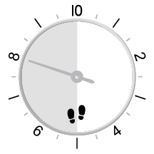
- If daily step is over 10000, Pedometer hand will
1000
move over the “0” and continue to count
from “0”

- Auto reset the Pedometer hand
In both cases, the watch will auto reset the pedometer hand to “0”
- If the watch sits still / lying idle ＞ 3 hrs
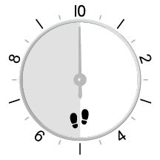
- If the sleeping mode has been detected ( sleeping＞ 3 hrs)

- Trip step counting
At any time and at any position, just press pusher for 3 seconds and the step counting hand will be reset to “0”, trip step counting will be activated

- Manual reset the pedometer hand
If you wake up the next day and find pedometer hand not at "0" position
- Press and hold the pusher for 3 seconds and release pusher, Pedometer Hand should turn one cycle go to “0” position
- if the hand doesn’t go to “0”, press once, and hand will move one time, keep pressing one time until it reaches “0”.
- Once Pedometer hand reaches “0” position release the pusher and wait 5 seconds, it will turn one cycle go to “0” position

- Change battery

If the pedometer hand is stopped and there has no reaction even the pusher is pressed, It means the pedometer battery has been running out, Please replace the battery immediately
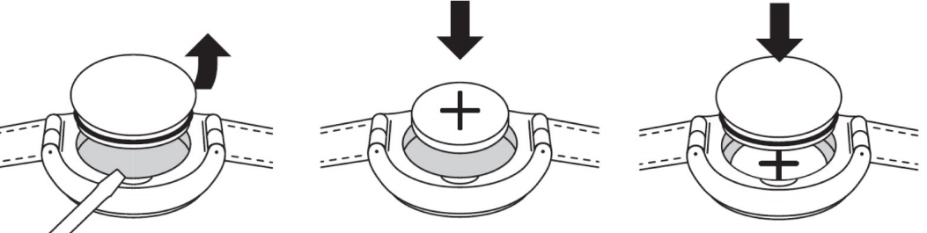

After the battery has been changed, the pedometer hand will turn to “0” automatically, If hand doesn’t go to “0”, follow point 6

Battery:
Battery type: CR2032H X1pcs
Battery Life: Approximately 1~1.5 year

NOTE: Battery life will vary due to different usage conditions

DANGER from batteries
- Keep new and old batteries out of reach of children.
- Batteries may be dangerous to life. Therefore, keep batteries and watch out of reach of infants.
- The battery must not be charged or reactivated by other means, disassembled, thrown into a fire or short-circuited.
- Danger of explosion if battery is replaced improperly. Replace battery only by the same or an equivalent type.
- Do not expose the battery to extreme conditions and make sure that empty batteries are removed from the watch immediately. There is an increased risk of leakage.
- lf battery acid has leaked, avoid all contact with skin, eyes and mucous membranes. lf you had contact with the acid, immediately rinse the affected areas with plenty of clear water and consult a doctor immediately.

Disposal
This marking on your Chum Connect indicates that it is not allowed to dispose your Chum Connect with other domestic waste, because batteries are hazardous waste. For the correct disposal of your Chum Connect, please contact your retailer, or use the provided battery container in the point of sales or in local collection points.
lf you want to separate from your Chum Connect, please dispose to the current regulations.
For further information, please contact the relevant authorities.
The packaging should be disposed according to the current regulations. For more information, please contact the relevant authorities.

